W311R (W311R+)-How to limit the computers to access the internet by MAC filter function (R)?
Product line: wireless Question category: function configuration

Q：Why we need to set the MAC address Filter?
A：Sometimes we want to limit some computers in the LAN to access the Internet; you can achieve this through MAC Address Filter.

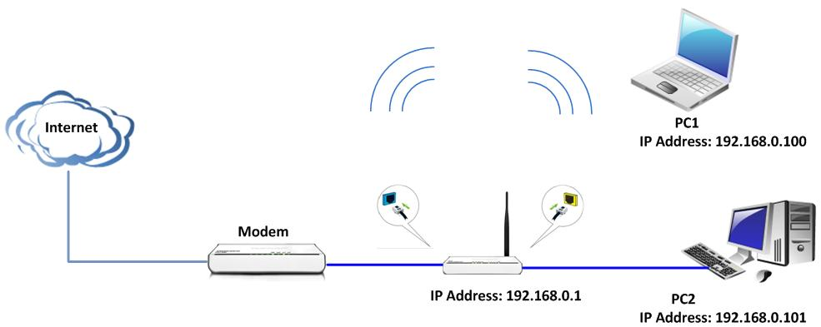

The steps are followings:
- You should know the MAC address of the computers which you want to limit to access the Internet. You can check them on the computers with command prompt. Click Start→Run. Type cmd and press Enter.

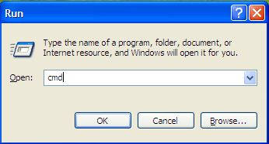

Type ipconfig /all at the prompt window, press Enter, it will show the MAC address and other `address information of this computer.

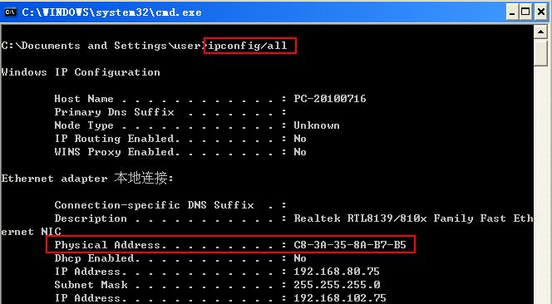

- Login to the management page of the router.
- Click Security Settings→MAC Filter in the gray menu on the left.
Tick the Enable for the MAC Filtering Settings

For example, we want to limit the computer with the MAC address C8-3A-35-00-EC-E5 to access the Internet from 8:00 am to 18:00 pm every day. And the computers with other MAC Address can access the internet. You can set the router following the picture as below.

